Pokhara University

Level: Bachelor | Semester – Spring | Year : 2005
Programme: BE |  | Full Marks : 100
Course: Network Theory |  | Time : 3hrs.

Candidates are required to give their answers in their own words as far as practicable.
The figures in the margin indicate full marks.

Attempt all the questions.

1. | - A series RLC circuit with R = 200Ω, L = 0.1H and C = 100 μF has a constant voltage of V = 200 V applied at t = 0. Find the equation for the transient current. Use classical method.  - In the circuit shown below the switch is moved from position 1 to 2 at t=0. Determine i, di/dt and d²i/dt² at t =0⁺.  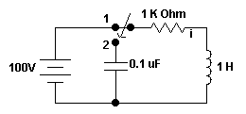 | 8  7
2. | a) In the circuit shown, the switch is moved from position 1 to 2 at t=0. Find the solution for I(t).  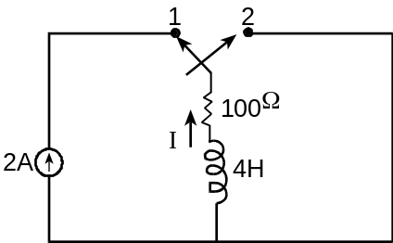  b) Obtain the solution for current I for the network shown. | 8  7
3. | a) For the network given below, obtain the voltage transfer function V2(s)/V(s).  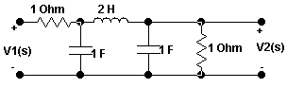  b) From pole zero plot, obtain the time domain response for 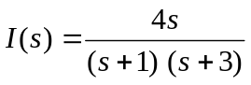 | 8  7
4. | a) Obtain asymptotic magnitude response for the following function. 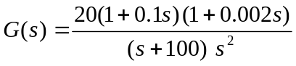  b) Find the trigonometric Fourier series for the waveform shown in figure  below:  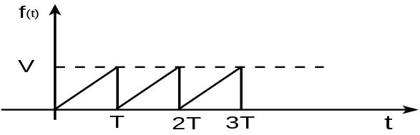 | 8  7
5. | - Synthesize the given impedance function in Foster – I and II forms.  - Check whether the given function is PRF or not. 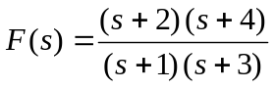 | 9  6
6. | a) The accompanying network shows a resistive network containing a single controlled source. Find z-parameter for the network.  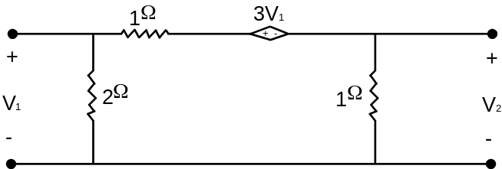  b) Find ABCD parameters for the network given below.  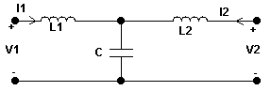 | 8  7
7. | Write short notes on (Any Two):  - Initial & final value theorem.  - Symmetrical and Reciprocal networks  - Properties of LC networks | 2x5

